## Team Member #3: Keegan Palonis

Group Topic: 2021 Data Viz Demographics

Your Topic/Question: Freelancer and Organizational Data

Describe the diversity YOU bring to the group (150 words or less):

I’m a Junior in Data Visualization with a double minor in Communications and Economics. I was previously a Physics major. I’ve held several leadership positions, such as the Boy Scouts of America, where I was both an Eagle Scout and the Senior Patrol Leader, which is the head of the entire troop. I have also been a part of marching band in both high school and here at Purdue. I have also done work in the data visualization field for my local school district, and I have experience communicating and presenting complex data in an easy-to-understand way.

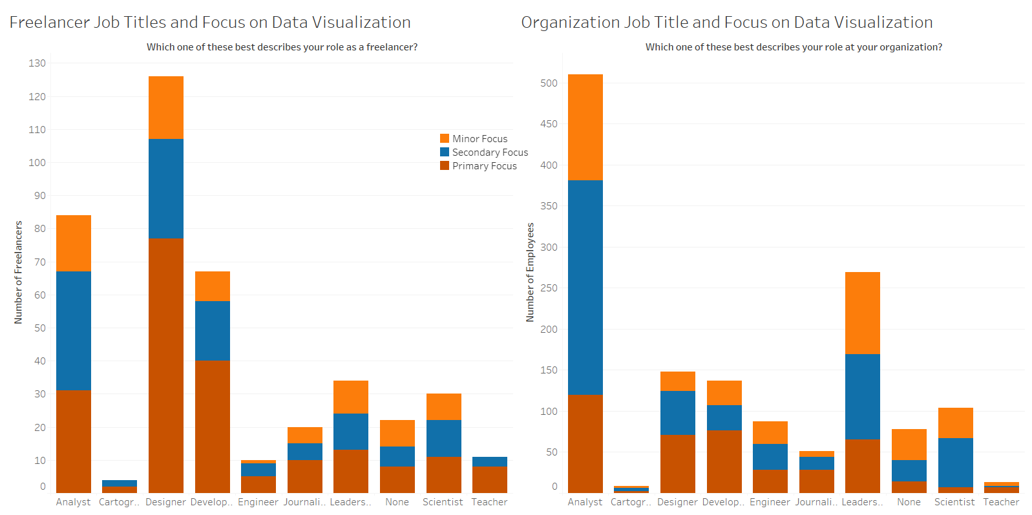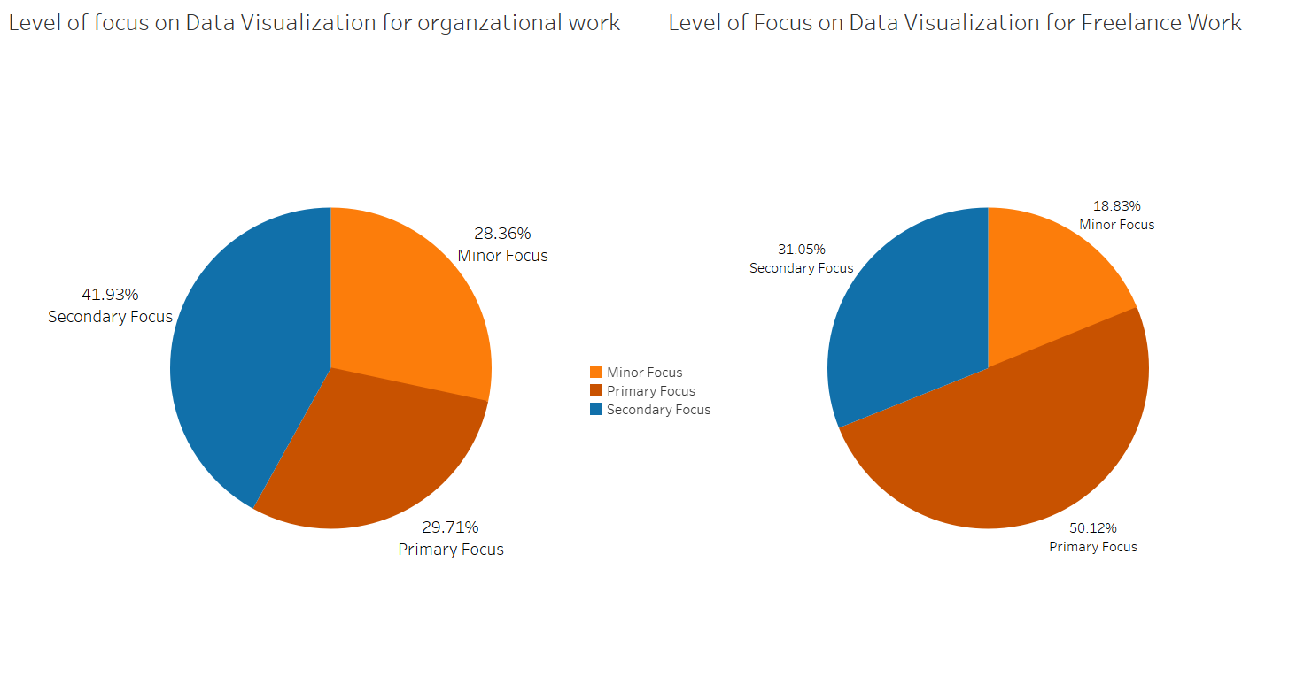

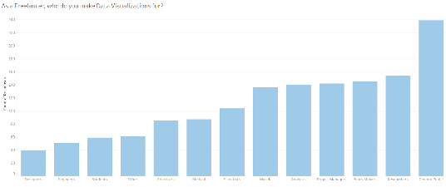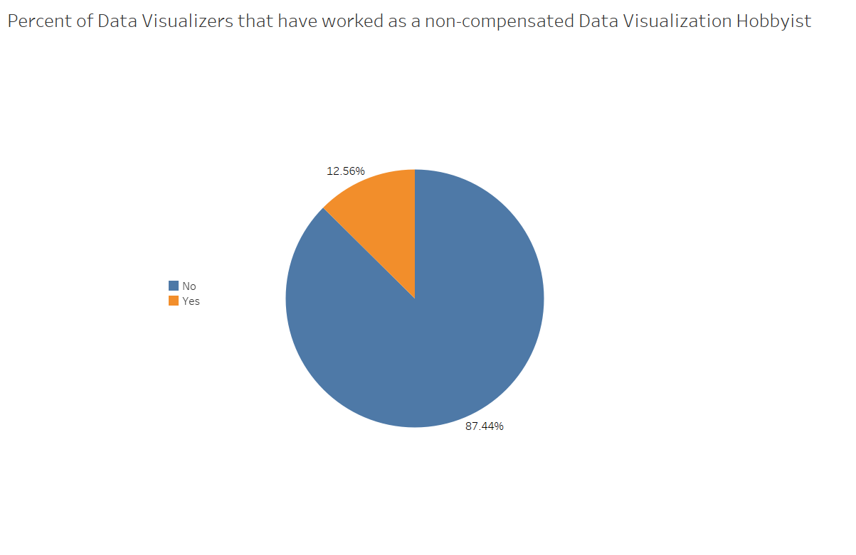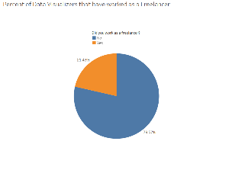

In the Hackathon, my responsibility was to look at what the portion of respondents that said that they had worked as a freelancer in the past year, as well as the level of focus that data visualization plays for both freelancers and organizations. I also looked at the percentages of people that stated they both worked as a freelancer, and as a hobbyist in order to get an idea of the size of the population in both sections. Overall, I contributed by building the website, participating and editing the five-minute video, as well as helping to hammer out a lot of the details in what we wanted to talk about both before and after the video, and making the visualizations above.

In my personal visualizations I mainly kept to bar, stacked bar, and pie charts. In the first visualization it shows the number of respondents per top title in both Freelance positions and Organizational positions, and the colors represent whether they responded that data visualization has a primary, secondary, or minor focus within their career. Next to that is a pie chart that shows the percentages of freelance and organizational workers that considered data visualization a primary, secondary or minor focus. With these, we tried to see if there was a major difference between the two in both job title and focus on data visualization, which you can see that there were some. The next bar chart shows who freelancers made visualizations, to compare to Rob’s Organizational bar chart of similar nature. The last to pie charts show the portion of respondents that said they had worked as either a freelancer or data visualization hobbyist in the last year, so we could further understand the portion of data visualizers that do either kind of work.

# Appendix F – Team Consensus

## Team Consensus

I have read and approve of the content as a representation of the team’s work and my contribution.

|  |  |  |  |  |
| --- | --- | --- | --- | --- |
| Robinson J. Witt |  | Robinson J. Witt |  | 4/28/22 |
| Print Team Member Full Name |  | Signature |  | Date |
| Noah Egierski |  | Noah Egierski |  | 4/28/2022 |
| Print Team Member Full Name |  | Signature |  | Date |
| Keegan Palonis |  | Keegan Palonis |  | 4/28/22 |
| Print Team Member Full Name |  | Signature |  | Date |
|  |  |  |  |  |
| Print Team Member Full Name |  | Signature |  | Date |

Save this document as:

**HackathonTeamName_CGT270Spring2022_FinalReport.pdf**